NOTICE IS HEREBY GIVEN THAT THE BOARD OF MANAGERS OF THE
WALKER COUNTY HOSPITAL DISTRICT, WALKER COUNTY, TEXAS, WILL HOLD A REGULAR MEETING, OPEN TO THE PUBLIC, ON WEDNESDAY,
AUGUST 23, 2023 BEGINNING AT 6PM AT 1300 11TH STREET HUNTSVILLE TEXAS 77340 AT THE FIRST NATIONAL BANK BUILDING
6TH FLOOR BLALOCK CONFERENCE ROOM

AGENDA

- Call meeting to order.

- Consider approving the minutes for the regular meeting held on July 26, 2023 .

- Comments from the public. If you wish to address the Board of Managers, please register prior to the meeting being called to order.

- Comments and reports from Huntsville Community Hospital Corporation administration.
- Review and consider approving the monthly financial reports.
- Consider approving payment of monthly bills.

- Adjourn meeting.

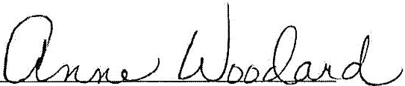

Anne Woodard, WCHD Chair

