NOTICE IS HEREBY GIVEN THAT THE BOARD OF MANAGERS OF THE
WALKER COUNTY HOSPITAL DISTRICT, WALKER COUNTY, TEXAS,
WILL HOLD A PUBLIC HEARING OPEN TO THE PUBLIC,
ON MONDAY, SEPTEMBER 25, 2023 BEGINNING AT 6PM
AT 1300 11TH STREET HUNTSVILLE TEXAS 77340
AT THE FIRST NATIONAL BANK BUILDING
6TH FLOOR BLALOCK CONFERENCE ROOM

AGENDA

- Call meeting to order.
- Public input regarding the possible 2023 tax rate increase.
- Discussion regarding the proposed 2023 tax rate increase and public input.
- Vote and adopt the 2023 tax rate increase.
- Adjourn meeting.

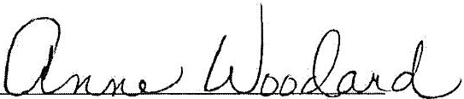

Anne Woodard, WCHD Chair

