NOTICE IS HEREBY GIVEN THAT THE BOARD OF MANAGERS OF THE
WALKER COUNTY HOSPITAL DISTRICT, WALKER COUNTY, TEXAS,
WILL HOLD A REGULAR MEETING, OPEN TO THE PUBLIC, ON WEDNESDAY,
MARCH 27, 2024 BEGINNING AT 6PM @
1300 11TH STREET HUNTSVILLE TEXAS 77320
@ THE FIRST NATIONAL BANK BUILDING
6TH FLOOR BLALOCK CONFERENCE ROOM

AGENDA

- Call meeting to order.

- Consider approving the minutes for the regular board meeting held on February 28, 2024.

- Comments from the public. If you wish to address the Board of Managers, please register prior to the meeting being called to order.

- Comments and reports from Huntsville Community Hospital Corporation administration.

- Review and discuss the Samuel Walker application to waive their 2024 taxes.

- Review and consider approving the monthly financial reports.
- Review payment of monthly bills.
- Report from Chairman Anne Woodard.
- Adjourn meeting.

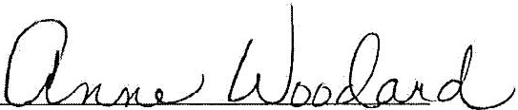

Anne Woodard, WCHD Chair

