NOTICE IS HEREBY GIVEN THAT THE BOARD OF MANAGERS OF THE

WALKER COUNTY HOSPITAL DISTRICT, WALKER COUNTY, TEXAS,

WILL HOLD A REGULAR MEETING, OPEN TO THE PUBLIC,

ON WEDNESDAY, AUGUST 14, 2024, BEGINNING AT 6:00 P.M.

AT THE FIRST NATIONAL BANK BUILDING

6TH FLOOR BLALOCK CONFERENCE ROOM

1300 11TH STREET HUNTSVILLE, TEXAS 77320

AGENDA

- Call meeting to order.

- Consider approving the minutes for the regular meeting held June 26, 2024.

- Comments from the public. If you wish to address the Board of Managers, please register prior to the meeting being called to order.

- Comments and reports from Huntsville Community Hospital Corporation Administration.

- Review and consider approving the monthly financial reports for June & July 2024.

- Review and consider approving the monthly bills for June & July 2024

- Approve Order Calling for the Walker County Hospital District Board of Managers’ General Election to be held November 5, 2024, for three (3) Managers to serve four (4) year terms each; and also appoint election judges, designate polling places and detailing provisions related to early voting.

- Authorize Joint Election Agreement between the County of Walker, City of Huntsville, City of New Waverly, City of Riverside, Huntsville Independent School District, New Waverly Independent School District and the Walker County Hospital District shall hold their respective general elections on Tuesday, November 5, 2024.

- Executive Session: The Walker County Hospital District Board of Managers will adjourn into a closed session to meet and discuss a potential real estate transaction and a potential litigation matter.
Adjournment to closed session is necessary and authorized by Section 551.001 and 551.072 of the Texas Government Code (the Open Meetings Act) which is necessary specifically, without limitation.
Any action as a result of this session will occur when open meeting is reconvened.

- Reconvene into Open Session to discuss any potential action needed from executive session and to vote if needed.

- Adjourn meeting.

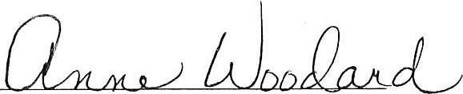

Anne Woodard, WCHD Chairman

